Unfortunately, a lot of this is stuff we don’t really have much expertise in doing, such as textures and sounds. Hopefully the sound design people will be able to do a good job.

Levels/Environments:

* NPCs should have idles/move/do something
* NPCs should have a different texture or look different
* Warden Gamsey needs something special to indicate status, like fancier armor
* Kitchen walls have a bad texture
* Dishes and stuff inside kitchen don’t look randomized enough
* Torches in kitchen don’t make that much sense, and don’t have a rigidbody
* NPCs in kitchen don’t have a hitbox
* Kitchen feels too tall and boxy, maybe a chandelier or hanging lights could fill the space
* Particles coming from the teleport pot are offset from the actual pot (for level one at least)
* Cave should be darker for more ambience, and then add more light shaft windows
* Torches near cave don’t have a rigidbody (also why is one of them so short?)
* Environment around kitchen when being spatula launched is plain green
* Texture messup on first rock in level 3

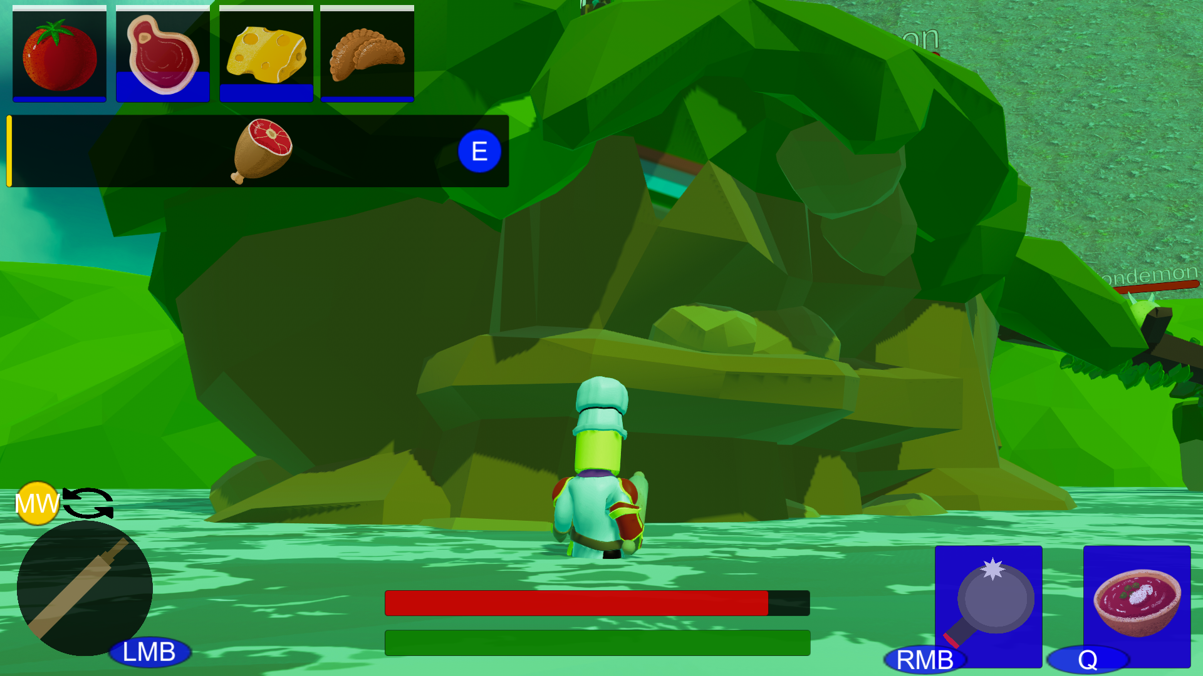

* Can’t walk up slope in level 4, near the Necreamancer
* Big building that slope is in looks too boxy and has bad texture
* Bridge to Necreamancer has weird texture on the side
* Extra islands in Necreamancer fight seemed pointless and strange

Player:

* Rolling onto the spatula cancels the launch animation
* Attacking doesn’t make a sound unless you hit (no shwooshing sound? Or it’s too quiet)
* Knife animation holds the knife at a strange angle
* Reset camera could be middle mouse button, t is awkward to press (maybe both?)
* Perhaps there should be an eating animation, so you must slow down/stop attacking while you are regaining health

Enemies:

* Crustacean invincibility lasts too long
* Crustacean transition into hide looks strange
* Fondemon idle sounds like the projectile shoot sound
* Fondemon didn’t aggro properly, combat music dequeued when I was fighting it
* Tomatroll jump hurtbox is mistimed
* Tomatroll idle is a “grrr,” but he doesn’t even open his mouth
* Snakon moving animation makes it look like it’s swimming, not slithering
* Snakon jumping animation sometimes doesn’t play (canceled out with back jump)
* Snakon should be faster or not be one shot (dark souls dogs?)
* Benedict laughs without his mouth moving
* Isobean projectile is a gray sphere
* Isobeans got stuck on each other and stopped moving forever (near start of level 2)
* Potatogre animations and transitions look clunky
* Potatogre boulder has no texture
* Potatogre texture looks weird, what are the yellow blotches?
* Beefcake has no particle effects besides fire, such as boulders hitting the ground, stomp shockwave, etc.
* Beefcake’s boulders disappear suddenly (perhaps they could crack apart or something)
* Beefcake should attack more, he walks into you a lot
* Beefcake is too simple, he just does all his attacks in order
* Beefcake’s meatlings should disappear when he dies
* Chipanzee walking animation makes him look like he’s sliding
* Chipanzee does nothing, they walk up to you and sit there idle
* Italernean hitbox seemed inconsistent sometimes
* Italernean food drop is easy to miss, and doesn’t look like pasta
* Fudge Sludge poison does too much damage
* Fudge Sludge poison hurtbox doesn’t change dynamically
* Cookie Wheel double hits player
* Cookie Wheel sound effects doesn’t sound like a cookie or a wheel
* Onion Knight hates slopes
* Onion Knight has strange interactions when a wall blocks him from player (hopefully I will fix this this week)
* Onion Knight out of bounds near Necreamancer
* Sprinkle Sprite is too high, frying pan passes underneath
* Gummy Bear/Zombie silver texture looks weird to me (maybe it just is too close to unity gray, and players wouldn’t notice)
* Necreamancer phylactery didn’t seem like a challenge, just stood there and pressed m1

Other:

* Basically everything UI (different font, buttons that aren’t plain boxes, etc.)
* Font is especially fuzzy and bad on “Present dish to finish level” in the tutorial
* Large black boxes and circles on screen when I first open tutorial
* There is a strange floating head next to tutorial hints (is that a character speech bubble?)
* Random crits with cleaver weren’t explained (neither were the other weapons, but they are more self-explanatory)
* Some powers said power locked even though I just unlocked them (still let me use them)
* Have to reselect powers every time I die
* Hard to tell what the green thing is in level 4 UI, looks like asparagus (I think it’s sprinkles)
* Cookie and Gummy Bear icons in level 4 doesn’t look like the cookie wheel or gummy bear respectively
* Since level 4 will be the last level for the foreseeable future, the “continue” should be disabled, or should enable a free roam section